2.2 Temporal Pattern Analysis
2.2.1 Overview
This section presents an analysis of Chicago crime data from 2015 to 2024, focusing on the temporal distribution of criminal incidents. By decomposing timestamps into Year, Month, Hour, and Day of Week, the data reveals that criminal activity in Chicago is not stochastic but follows highly structured, predictable temporal patterns. These regularities suggest that static resource allocation models are likely inefficient and that policing strategies should align with the specific temporal rhythms of the city.
2.2.2 Yearly Trends: Structural Disruptions
The longitudinal analysis highlights distinct phases in crime trends. The period from 2015 to 2019 was characterized by relative stability. However, 2020 marked a significant structural break driven by the COVID-19 pandemic:
The "COVID Effect": Aggregate crime declined by approximately 24% during 2020–2021. This reduction aligns with Routine Activity Theory, as lockdowns reduced the convergence of suitable targets and offenders in public spaces.
The Divergence: A distinct divergence occurred between crime types. While property crimes (e.g., theft) decreased due to reduced commercial activity, violent crimes—specifically shootings—increased significantly during the same period.
Post-Pandemic Rebound: Data from 2023–2024 indicates a rebound in total crime numbers. This is largely attributable to a specific surge in Motor Vehicle Thefts, correlated with the "Kia Boyz" social media trend which exposed security vulnerabilities in certain vehicle models, altering the opportunity structure for offenders.
2.2.3 Periodicity: Cyclical Regularities
A defining characteristic of the dataset is Periodicity—the robust tendency of crime to repeat identical patterns over specific time intervals. This cyclical nature suggests that crime operates like a waveform with predictable peaks and troughs.
Seasonal Oscillation: The seasonal data forms a consistent sine wave. Regardless of annual crime levels, the shape of the curve remains constant, troughing in February and peaking in July/August. This indicates that environmental factors, such as temperature, regulate the frequency of human interaction and, consequently, crime.
The Weekly "Pulse": Micro-temporal analysis reveals a shorter, high-frequency cycle. Violent crime exhibits a distinct "pulse" every weekend, intensifying specifically on Friday and Saturday nights (21:00 – 02:00).
Circadian Separation: There is a clear temporal separation between crime categories. Property crimes peak during business hours (09:00 – 18:00), while violent crimes are concentrated during nocturnal hours, effectively creating two distinct temporal environments for policing.
2.2.4 Conclusion
The central finding of this analysis is the high degree of predictability inherent in the crime data. The stability of these periodic cycles—the seasonal wave and the weekend pulse—implies that crime trends can be forecasted with reasonable accuracy. Consequently, the data supports a transition from static shift schedules to a predictive staffing model, where resources are dynamically scaled to match these established temporal risk profiles.
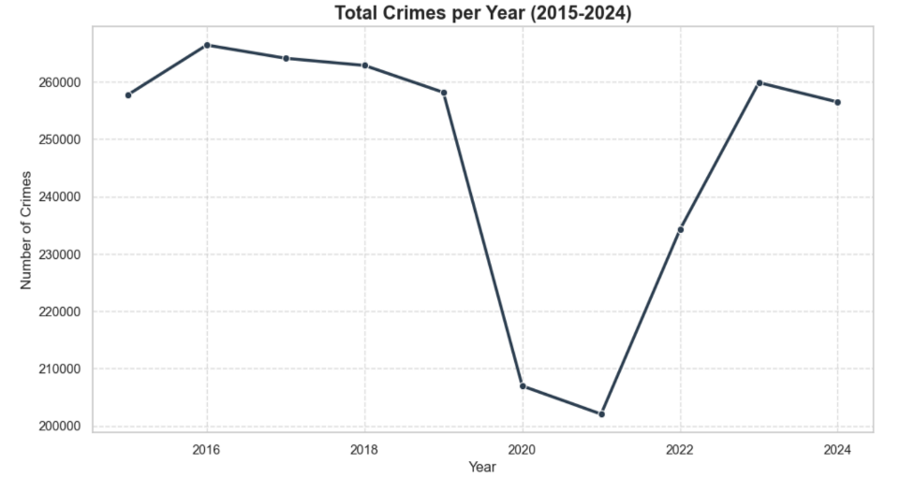
Figure 2.2.1
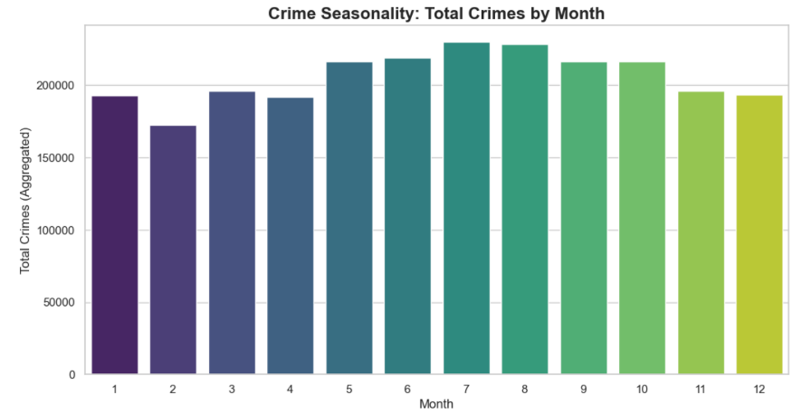
Figure 2.2.2
Figure 2.2.3

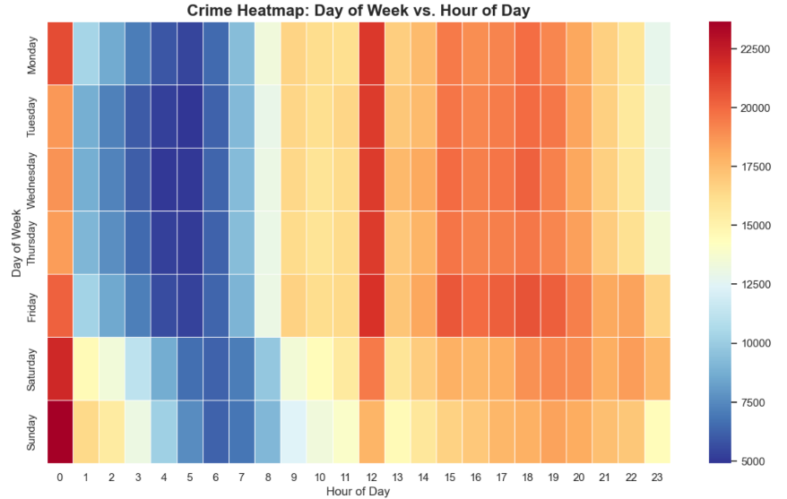

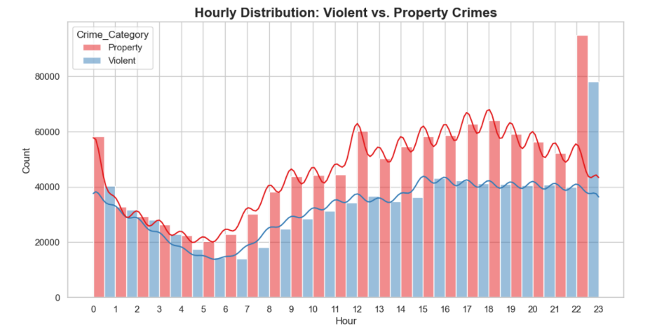
Figure 2.2.4

3.1 时间模式分析 (Chinese Translation)
3.1.1 概述
本节分析了 2015 年至 2024 年的芝加哥犯罪数据，重点关注犯罪事件的时间分布。通过将时间戳分解为年、月、小时和星期，数据显示芝加哥的犯罪活动并非随机，而是遵循高度结构化、可预测的时间模式。这些规律表明，静态的资源分配模型可能效率低下，警务策略应与城市的特定时间节奏保持一致。
3.1.2 年度趋势：结构性破坏
纵向分析突显了犯罪趋势的不同阶段。2015 年至 2019 年期间表现出相对的稳定性。然而，2020 年标志着由 COVID-19 大流行驱动的重大结构性断裂：
“COVID 效应”： 2020-2021 年间，犯罪总数下降了约 24%。这种减少符合日常活动理论 (Routine Activity Theory)，因为封锁减少了合适目标与犯罪者在公共场所的交汇。
分化现象： 犯罪类型之间出现了明显的分化。虽然由于商业活动减少，财产犯罪（如盗窃）有所下降，但在同一时期，暴力犯罪——特别是枪击事件——却显著增加。
大流行后的反弹： 2023-2024 年的数据显示犯罪总数有所回升。这主要归因于机动车盗窃案的激增，这与“起亚男孩 (Kia Boyz)”社交媒体趋势相关，该趋势暴露了特定车型的安全漏洞，改变了犯罪者的机会结构。
3.1.3 周期性：循环规律
该数据集的一个显著特征是周期性 (Periodicity)——即犯罪倾向于在特定时间间隔内重复相同模式的稳健趋势。这种循环性质表明，犯罪的运作就像一个具有可预测波峰和波谷的波形。
季节性振荡： 季节性数据形成了一个一致的正弦波。无论年度犯罪水平如何，曲线的形状都保持不变，在 2 月达到低谷，在 7 月/8 月达到顶峰。这表明温度等环境因素调节着人类互动的频率，从而调节犯罪频率。
每周“脉冲”： 微观时间分析揭示了一个更短、更高频的周期。暴力犯罪在每个周末都会呈现明显的“脉冲”，特别是在周五和周六晚上 (21:00 – 02:00) 加剧。
昼夜分离： 犯罪类别之间存在清晰的时间分离。财产犯罪在营业时间 (09:00 – 18:00) 达到高峰，而暴力犯罪则集中在夜间，这实际上为警务工作创造了两个截然不同的时间环境。
3.1.4 结论
本分析的核心发现是犯罪数据中固有的高度可预测性。这些周期性循环的稳定性——季节性波动和周末脉冲——意味着可以以合理的准确度预测犯罪趋势。因此，数据支持从静态轮班时间表向预测性人员配置模型的转变，即根据这些既定的时间风险概况动态调整资源规模。

